**Predictive Analytics for Enhancing BBY's Loyalty Program**Written Supplement

Michael Charara

13.2023

[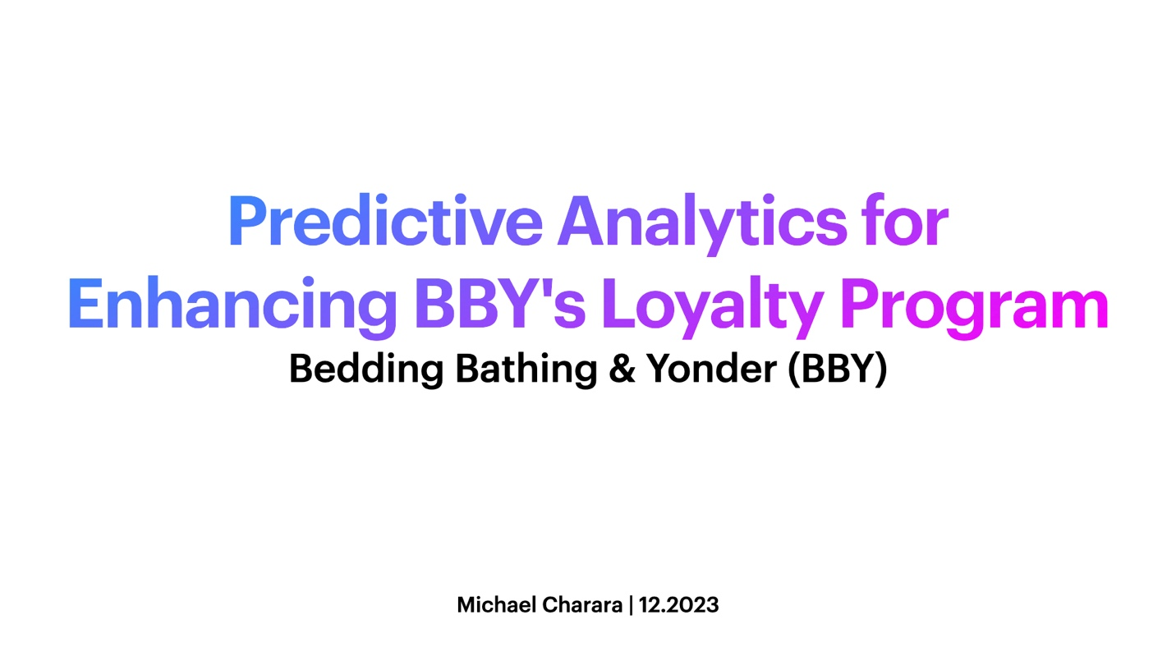](https://youtu.be/_vUnTNHDpJ0)

Video: <https://youtu.be/_vUnTNHDpJ0>

**Executive Summary**

At Bedding Bathing & Yonder (BBY), we harness data to optimize customer engagement and drive sales. This report highlights our predictive model derived from analyzing a customer base of 15,000 households across purchasing habits, donation histories, and more. Through a rigorous process from data collection to analysis, we've crafted a model that predicts spending and deciphers key expenditure drivers. These insights guide tailored marketing strategies, providing BBY's leadership with evidence-based decisions for revenue growth and empowering targeted campaigns. This streamlined approach cements BBY's position as a data-savvy leader in the retail sector.

**Introduction**

At Bedding Bathing & Yonder (BBY), we leverage advanced data analytics to enhance customer experience and catalyze revenue growth. Our dedicated team has embarked on an analytical voyage, utilizing predictive modeling to gain actionable insights into our customer base. With a rich compilation of data from various sources – spanning purchasing habits, donation records, internal membership details, magazine subscriptions, and political orientations – we are crafting a nuanced understanding of our customers. This multifaceted dataset, strengthened by additional third-party data, forms the bedrock upon which we build models to forecast household revenue and inform targeted marketing strategies.

**Data Cleaning and Preprocessing**

The cornerstone of predictive accuracy lies in the bedrock of data integrity. Our data-cleaning odyssey involved critically assessing missing values and employing strategic imputation techniques to safeguard the dataset's authenticity. We embarked on a rigorous preprocessing journey, meticulously transforming and standardizing the data to ensure its preparedness for the sophisticated modeling that lies ahead. From scrutinizing distributions to normalizing scales, we refined our dataset to a state of analytical readiness, ensuring that the subsequent stages of model training, validation, and testing rest on a foundation of reliable and robust data.

This enhanced narrative underscores the project's goals and the meticulous steps taken in the data preparation phase, reflecting the complexity and the strategic approach outlined in the provided code snippets and project scenario. It communicates a professional tone suitable for a high-level executive summary, showcasing the data-driven decision-making process at BBY.

Figure 1: R codes showing the standardization of the values.

**Exploratory Data Analysis (EDA)**

At Bedding Bathing & Yonder (BBY), our Exploratory Data Analysis (EDA) employed histograms, boxplots, and correlation matrices to distill key spending patterns from our customer data, informing our model selection. We chose XGBoost, Random Forest, and Linear Regression for their effectiveness in behavioral prediction. These models underwent comprehensive training on a curated dataset, reflecting the complexity of customer profiles. Rigorous validation confirmed their accuracy, with RMSE metrics indicating predictive solid capabilities for future BBY marketing strategies.

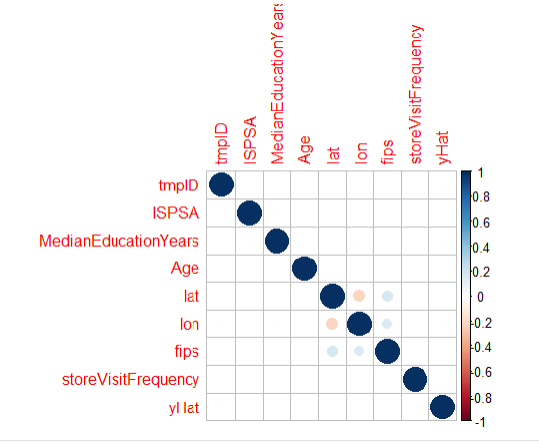

Figure 2: Correlation Plot of Numeric variables

Figure 3: Distribution of yHat values

**Modeling Approach**

At Bedding Bathing & Yonder (BBY), we prioritize understanding customer spending through a strategic modeling approach. We utilized XGBoost for its speed, Random Forest to minimize overfitting and Linear Regression for baseline linear analysis. These models were fine-tuned on a dataset reflective of BBY's varied customer base, ensuring precise prediction of household revenue.

**Model Evaluation**

The model effectiveness was gauged using Root Mean Square Error (RMSE), ensuring the model's fit and generalization. The Random Forest model emerged as the most robust, showing superior predictive abilities for enhancing BBY's marketing strategies and revenue generation.

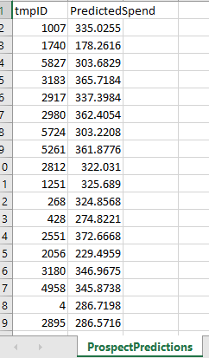**Prospect Predictions**

The true benchmark of our predictive modeling lies in its prowess to forecast the spending patterns within an untapped demographic—our prospects. At BBY, our adeptly trained models have been put to the test, projecting the spending behaviors of potential customers with remarkable detail. These forward-looking predictions are not merely numerical forecasts but strategic assets that arm our marketing division with the acumen to design personalized and precision-targeted campaigns. Our models, especially the Random Forest with its standout RMSE scores, demonstrate a robust capability to navigate through the intricacies of consumer spending, enabling us to anticipate and act upon future market trends proactively.

Figure 4: Predicted household spendings

**Key Findings and Implications**

Figure 5: Model Comparison Results

**Insights**

The variance in RMSE values across models underscores the significance of model selection and training. Notably, the Random Forest model's exceptional performance in predicting household revenue reflects its adeptness at mapping out the complex purchase patterns of BBY's dedicated customer base. Visual analytics, such as the exploration of Median Education Years, reveal profound connections between educational attainment and spending habits, insights that are pivotal in sculpting targeted marketing initiatives. Similarly, the consistency observed in in-store visit frequencies via boxplots speaks to a highly competitive retail environment ripe for strategies that bolster in-store engagement.

Custom-tailored marketing approaches, informed by these model-based predictions, are instrumental in refining BBY’s customer outreach. Such data-informed strategies enable the marketing team to craft offers and promotions that resonate with customer preferences and bolster BBY's revenue.

**Conclusion and Recommendations**

We introduce a comprehensive household revenue model resulting from a detailed and validated analysis. This model provides valuable insights for strategic decision-making, aligning with BBY's broader business goals and reinforcing our focus on customer-centric retailing. We recommend integrating these insights into BBY's strategic plans, ensuring that our marketing initiatives are in sync with the company’s mission and responsive to market dynamics. This balanced approach will guide BBY in responding to market trends and proactively shaping them.